REPORT
COLLOQUIUM ON INTEGRATING ENVIRONMENTAL LAW TRAINING IN JUDICIARIES IN AFRICA
25-27 JANUARY 2017

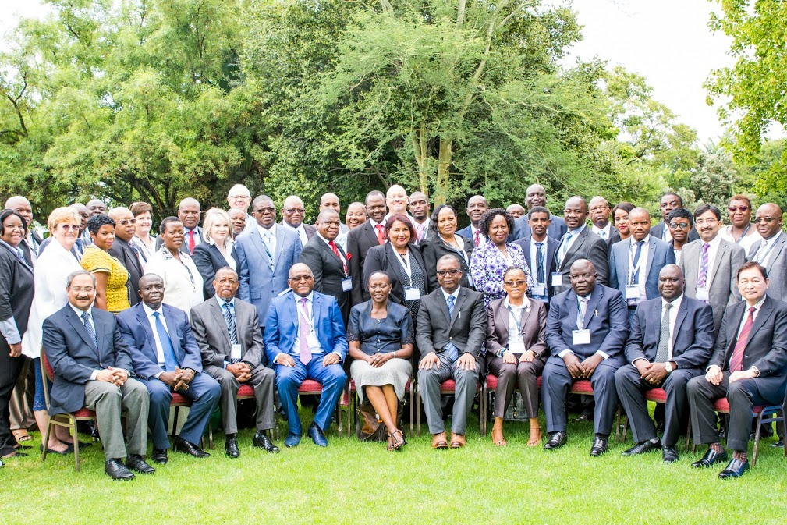Group photo of all participants
INDEX
- Background
- Opening of the Colloquium
- Overview, Objectives and Introduction of the Program
- State of the Environment in Africa
- Open Discussion
- Resolution of Environmental Disputes
- Challenges encountered by the legal profession when dealing with environmental cases.
- Public participation in Judicial process.
- Current status of Environmental Training in Judicial Training Schools in Africa
- State of Judicial Environmental Law Training in Africa.
- Sustainable integration of Environmental law in Judicial Training Curricula: Sharing best Practices on Steps, Processes, Challenges and Solutions.
- Scope and Content of Environmental law.
- Key Content of Judiciary Environmental Training Manuals.
- Framework for Developing and Implementing Judicial Training Program on Environmental Law in Africa.
- Group Presentations
- Annexures: Johannesburg Plan of Action

DAY 1: 25 JANUARY 2017
- BACKGROUND
The United Nations Environment Program (UNEP) in collaboration with the South African Judicial Education Institute (SAJEI) hosted a Colloquium on Integrating Environmental Law Training into Judicial Curricula in Africa from 25th to 27th January 2017 at Indaba Hotel, Fourways, Johannesburg, South Africa. The Colloquium was attended by delegates from 18 African and three Asian countries. The majority of the delegates were Judges who are the Heads of Judicial Institutes in their respective countries.
The long-term objective of the Colloquium and associated outcomes is to support countries to mainstream and integrate course elements on environmental law in Judicial Training Institutes as part of a sustainable curricula. The expected results were:
- Incorporate environmental law in a number of curricula of Judicial training institutes in Africa;
- Impart skills on ways to sensitize and/or train the Judiciary on environmental law in African countries;
- Develop a team of trainers on environmental law for the Judicial Training Institutes in Africa;
- Develop a manual for integrating environmental law for Judiciaries in Africa.
- Establish a Network of Judicial Education Institutes.

- OFFICIAL OPENING OF COLLOQUIUM
On behalf of the South African Judicial Education Institute (SAJEI) chaired by the honorable Chief Justice Mogoeng Mogoeng, Dr Moshoeu welcomed the delegates to the epic event of finding ways to integrate environmental law into judicial curricula on a sustainable basis in Africa. Dr Moshoeu indicated that Ms Mmeme Sejosengwe, Secretary General of the Office of the Chief Justice could not attend due to other urgent commitments conflicting with the event. Dr Moshoeu acknowledged the presence of Heads of Judicial Institutes from 21 countries and expressed gratitude for their participation.
Dr Moshoeu alluded to the topics that will be covered during the Colloquium and indicated that the sessions will provide participants with essential and critical knowledge on how to make the judicial curricula diverse and interesting for the Judicial audience.
Dr Moshoeu expressed gratitude to UNEP and SAJEI teams for working tirelessly on organizing the Colloquium. Special thanks went to Ms Elizabeth Mrema’s leadership to ensure that the Colloquium takes place and also to her presence despite her hectic schedule. Dr Moshoeu appealed to the participants to ensure a successful implementation of the outcome of the Colloquium. Lastly, Dr Moshoeu declared the Colloquium opened and wished the delegates successful engagements.
Dr Gomolemo Moshoeu: Chief Executive Officer, South African Judicial Education Institute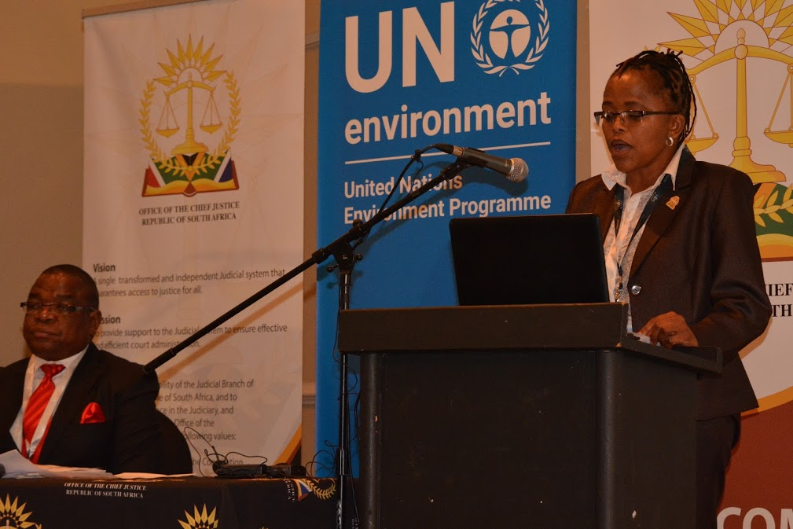
Remarks by UN Environment: Ms Elizabeth Mrema, Director, Law Division
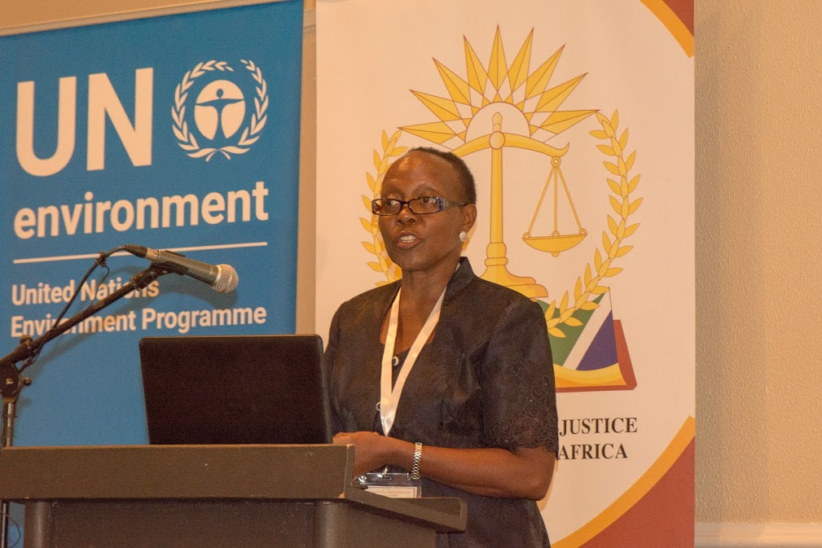
In her opening remarks, Ms Elizabeth Mrema highlighted the importance of adopting a Regional approach towards sustainable integration of environmental law into judicial curricula. Ms Mrema indicated that the participants should ask themselves critical questions on guiding principles for developing environmental programs and how to address resource constraints. Ms Mrema listed the judiciary initiatives that UNEP has participated in starting from the l Colloquium of Judges in 1996 to a similar event in 2002. Mr Mrema wished that the 2017 Colloquium should give birth to epic developments in the training of Judiciary on environmental law.
Ms Mrema listed the following proposals:
- Commitment to developing Africa-wide training program taking into account different legislation.
- Establishment of a network of Judicial Training Institutes.
Ms Mrema indicated that it will be advisable to consider a Regional symposium at a later stage to assess the effectiveness of the outcome of the Colloquium.
- OVERVIEW, OBJECTIVES AND INTRODUCTION OF THE PROGRAMME: MR M RAMALEBANA, SAJEI JUDICIAL EDUCATOR
Mr Ramalebana stated that the greatest enemy of the environment is man. Man differ from animals because he kills and dissipate the environment as a result the future generation is at a disadvantage.
Mr Ramalebana indicated that the Colloquium is aimed at addressing these unfortunate phenomena and emphasis will be placed on the importance of incorporating environmental laws into judicial training. Mr Ramalebana highlighted that there are some few aspects that we would be looking into during the three days namely sustainable development, networking, best practices, benchmarking, judicial manual and curricula. These are not a litmus of everything expected from us but can serve as a basis for our ongoing discussion.
At the end of the program we should be in a position to identify the challenges relating to judicial training and create a forum for assistance of undeveloped Institutes. Mr Ramalebana emphasized the need for train the trainer courses so that countries can be in a position to sustain the initiative of integrating environmental law into judicial curricula.
- SESSION I: STATE OF THE ENVIRONMENT IN AFRICA: ROBERT WABUNOHA: UN ENVIRONMENT
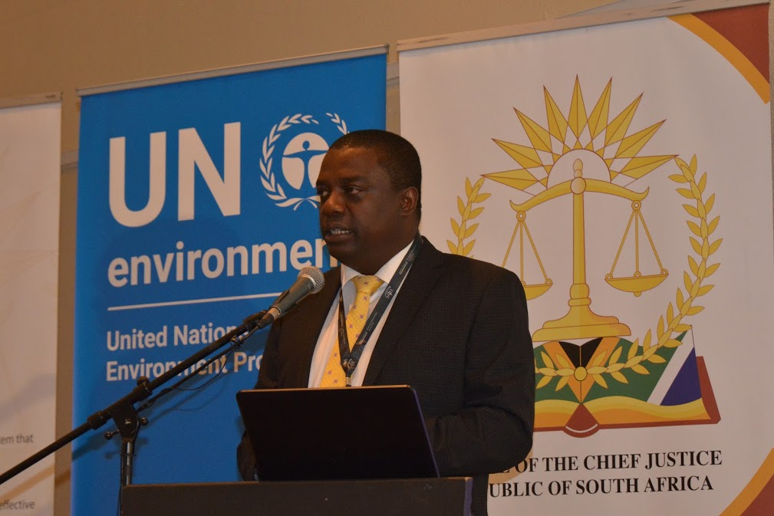
Mr Wabunoha shared environmental issues at regional levels including trans-boundary aspects. Mr Wabunoha indicated that illegal trade in wildlife species, poaching and illegal trade in wildlife causes a loss of about $10.9 billion per annum. In many countries there are issues that hamper integration of environmental law into judicial curricula such as inadequate capacity, lack of proper planning, no technical knowledge expertise, weak enforcement, lack of financial and technical resources. .
For detailed presentation please check http://www.judiciary.org.za/unep-colloquium.html
- OPEN DISCUSSION
Malawi: The challenges in Malawi are largely poor agricultural practices as well as fauna and flora. There is a need for a balance between development and environmental preservation.
Pakistan: There is a danger of over-criminalizing environmental matters, the Judiciary should consider reducing the criminal component and focus on restorative justice. Judges act as opinion makers and contribute towards awareness in the society.
South Africa: Although the Judiciary is aware of environmental issues, there is a need for continuing judicial training. It is imperative that the Judiciary take the leadership on these issues.
Cameroon: The role of Judges in environmental matters has to be clearly articulated.
Uganda: Problems on environmental issues comes from ignorance, lack of political will and outward greed.
Kenya: There was reference to environmental issues emanating from the Game park and a Mombasa judgment on port related matters.
- RESOLUTION OF ENVIRONMENT DISPUTES
Panelists: Mr Namudi (Uganda); Mr Daniel Ndayisaba (Rwanda); Ms Mokshda Pertaub (Mauritius); Justice Ali Najafi (Pakistan)
  - Mr Namudi (Uganda)
Mr Namudi indicated that responsiveness to environmental matters is generally very slow. It takes ages for such matters to go through the courts. There are civil procedure rules which provide for mediation. It is mandatory for civil matters to go through mediation before being placed on the court roll. The general challenges in dealing with environmental matters are as follows:
- Poor enforcement of orders.
- Apparent lack of political will.
- Weak governmental environmental government entities.
- Lack of specialized environmental expertise.
It has been recommended that there should be proper funding and development of specialist courses on environmental matters.
For detailed presentation please check http://www.judiciary.org.za/unep-colloquium.html
  - Mr Daniel Ndayisaba, (Rwanda)
The Institute provides training to criminal justice stakeholders. The is Kigali International Arbitration Centre. There is no university offering environmental law.
For detailed presentation please check http://www.judiciary.org.za/unep-colloquium.html
  - Justice Ali Baqar Najafi, (Pakistan)
Justice Najafi explained the legislative environmental regime and Alternative Dispute Resolution mechanism in Pakistan. He summarized the Acts that regulate environmental issues such as Pakistan Environmental Protection Ordinance of 1983, Pakistan Environmental Protection Act of 2014, Baluchistan Environmental Protection Act of 2012 and the Punjab Environment Protection Act of 1997 (Amended 2012). The use of ADR against the option of court is done for the expeditious disposal of the issue although the consent of parties is mandatory.
For detailed presentation please check http://www.judiciary.org.za/unep-colloquium.html
- CHALLENGES ENCOUNTERED BY THE LEGAL PROFESSION WHEN DEALING WITH ENVIRONMENTAL CASES
  - Advocate P. Lazarus SC (South Africa)
Adv Lazarus highlighted that it is critical to understand the concept of sustainable development. There are challenges regarding balancing environmental protection, social development and economic development. It is not a simplistic equation and therefore requires attention. One has to make sure that the pendulum should not swing to the extreme when considering the three dimensions.
Adv Lazarus listed three challenges namely;
- Conceptual challenge: The definition of sustainable development.
- Practical challenges: Statutory landscape changes all the time. There is a high volume of vast legislation in South Africa.
There is perceived turf war between the department of Mineral Resources and Department of Environmental Affairs. Available legislation is found to be irreconcilable. Cases on waste are found to be incredibly difficult as one man’s waste is another man’s food. It is important for one to understand the development of the law as well as its technical nature. Environmental management is a new field with divergent views.
- PUBLIC PARTICIPATION IN JUDICIAL PROCESSES
Panelists: Mr Benson Ochieng (Kenya); Ms Abena Ayesu (Ghana)
8.1. COURT USERS COMMITTEES IN EAST AFRICA: MR BENSON OCHIENG: KENYA
Over the decades, human generation developed expertise to adjudicate on matters of conflict. After the democratic changes in Africa in the 1990s and 2000s courts were forced to be relevant and responsible. For example the Kenya Constitution 2010 is very strong on public participation. Article 159(1) requires the judiciary in the exercise of its judicial authority to recognize that it is wholly derived from the people and Article 159(2) (c) requires Judiciary to be guided by principles of ADR. In East Africa, there is a strong reliance on CUCs as a mechanism for strengthening the judicial process. The Court Users Committees (CUCs) can enhance confidence and efficiency in resolving disputes especially in technical areas like land and environment.
8.2. COURT USERS COMMITTEES IN EAST AFRICA: MS ABENA AYESU: GHANA
In West African countries Court Users Committee (CUC) is a body that is used to bring the administrators of Justice and the Court users together to address challenges and propose recommendation for implementation. Article 125 of the Constitution provides that Justice emanate from the people and shall be administered in the name of the Republic by the Judiciary which shall be independent and subject only to the Constitution. Principle 10 of the Rio Declaration provides for access to information, public participation and access to justice.
In Ghana, Court Users Committee is a faceless entity which cannot be influenced. There is assistance received from UNODC office in developing public confidence in the Judiciary and enhance access to courts. The main functions of the office are to create awareness, establish a complaint unit which have been decentralized to the lower courts. In Liberia, there is no Court Users Committee but they have developed a manual for Court Users in three major languages. The CUCs should be expanded to incorporate environmental experts.
9. SESSION II: CURRENT STATUS OF ENVIRONMENTAL TRAINING IN JUDICIAL TRAINING SCHOOLS IN AFRICA
Panelists: Dr G Moshoeu (South Africa);Justice Sir Dennis Adjei (Ghana); Justice Dr. C. Kachale (Malawi); Justice Otieno-Odek (Kenya); Ms Mokshda Pertaub (Mauritius); Justice Lebohang Molete (Lesotho); Gilbert Tor (Nigeria)
9.1. Dr G Moshoeu (South Africa)
The purpose of the Institute is to provide Judicial education as enacted in the South African Judicial Education Institute Act of 2008. SAJEI responsibilities are research, support to foreign judicial institutions, provision of judicial education to Magistrates and Judges as well as to those who are aspiring to be Judicial officers. SAJEI governance structures consist of the Council chaired by the Chief Justice and Committees. The Secretary General is the Accounting officer of the Institute.
The Institute has conducted training for Magistrates on environmental law covering the following topics: endangered snakes, adjudicating environmental offences and related organized crimes, biodiversity crime in Africa, South African biodiversity legislation. The challenges facing the Institute are lack of curriculum on environmental matters, lack of Judicial trainers specialising on environmental matters and inadequate funding.
9.2. Justice Sir Dennis Adjei (Ghana)
Sir Adjei provided a historical perspective on the Judicial Training Institute in Ghana. The training of Judges was on ad-hoc basis for the senior, junior and newly-appointed Judges. In mid-1970s, training was implemented for the Magistrates and in the 1980s it was extended to continuing education for Judges. The Institute was transformed in 1995 to become the Institute of Continuing Judicial Education of Ghana (ICJEG). Further changes took place in 2004, the Institute was renamed Judicial Training Institute (JTI) and a Director was appointed on full-time basis. JTI develops and delivers programs for the current and new members entering the Judiciary. Judges and Magistrates are kept abreast on recent developments, law including environmental aspects.
9.3. Justice Dr. C. Kachale (Malawi)
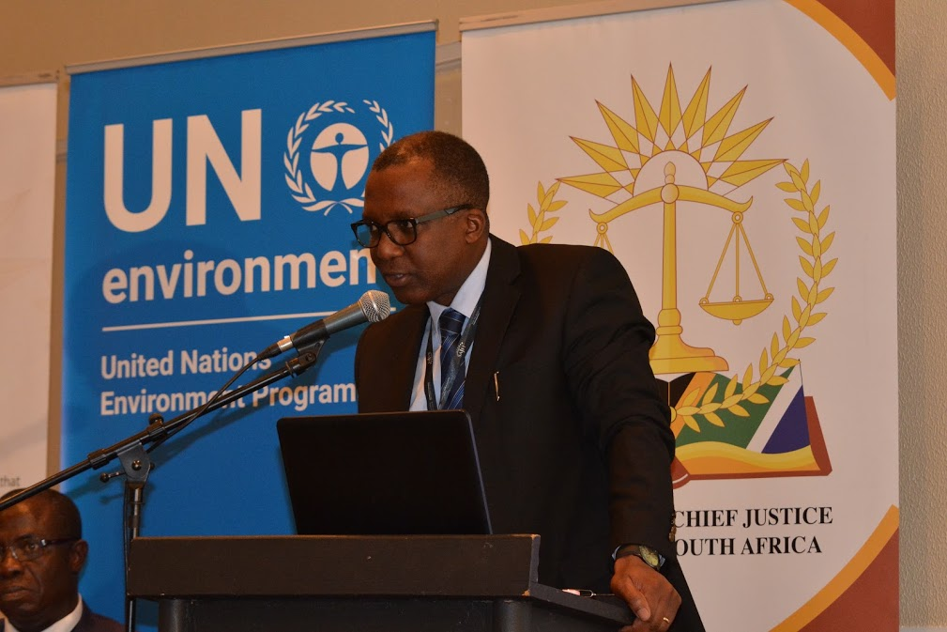
The Judiciary of Malawi is the branch of the government of Malawi. The Judiciary interprets and applies the laws to ensure equal justice and to provide a mechanism for dispute resolution. The legal system of Malawi is grounded in English law and was modified in 1969. The Constitution defines the Judiciary as a hierarchical system of courts, with the highest court being a Supreme Court of Appeal. Since 1994, the Constitution was transformed and legal system became pro-poor. There is not yet a formalized Judicial institute. However, many of the training is conducted by senior Judges. In 2011, there was an attempt to develop a framework to deal with structural relationships between courts and other institutions.
9.4. Justice Prof Otieno-Odek (Kenya)
The Judiciary Training Institute (JTI) was established in 2008 with the aim of providing Judicial education to Judges and Magistrates. The JTI has developed and is one of the leading institutions in Kenya and Africa on Judicial education. It has offered many environmental courses.
The Constitution of Kenya was amended in 2010 which stipulates that Judicial Service Commission should offer continuing education and training to Judges and Judicial Officers. This responsibility has been delegated to the JTI and it conducts several programs and seminars, public lecture and other forms of discourses.
Amongst others, JTI offers substantive law, evidence and procedure, judicial skills, leadership and management skills. The courses may also include social and community issues. The institute also work on various policy formulation of internal use by the Judiciary and for purpose of administration of justice. JTI has several links with institutions like UNEP and other regional, international institutes and government and non-government organizations. JTI participants in the Commonwealth Judicial Education Institute.
9.5. Ms Mokshda Pertaub (Mauritius)
There are about 800 law practitioners (barristers, attorneys and notaries) in private practice and about 100 legal officers at the Attorney General’s Office. There are 71 judicial officers consisting of 20 Supreme Court Judges, 1 Master and Registrar, 1 Deputy Master and Registrar and 49 Magistrates.
In 1997 there was a Presidential Commission which reported on the structure and operation of the judicial system and legal professions. The Commission highlighted lack of formal arrangement in the training of Judicial Officers after they were appointed. The Commission recommended that Judicial Studies Board be given responsibility to set-up induction course and continuing judicial education of Judges and Magistrates at various levels. As a result in October 2011, the Institute for Judicial and Legal Studies was proclaimed.
The Institute has a mandate to organize the CPD program which is compulsory for law practitioners and legal officers. Non-compliance has adverse effects on the right to practice. If one want to be appointed as a Judge, Magistrate or Legal officer one must follow a course approved by the Institute. There has not been any environmental law training for Judges in Mauritius.
9.6. Judge Lebohang Molete (Lesotho)

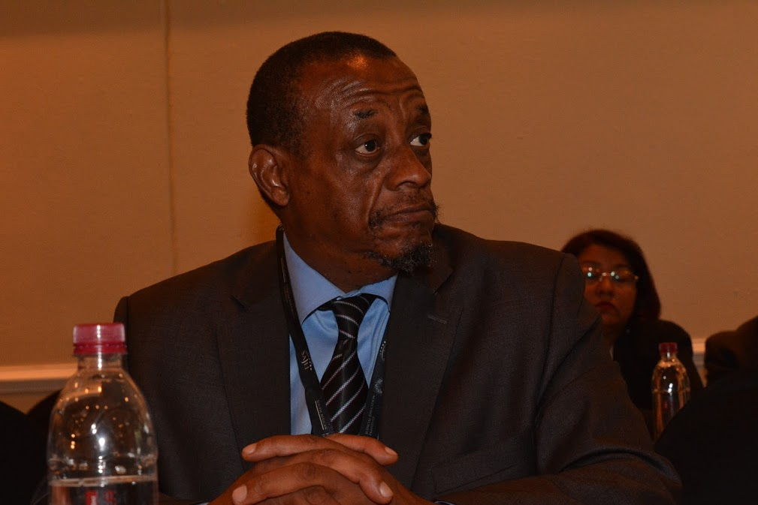
Judge Molete stated that there is no Judicial Education Institute dedicated to the training of Judicial officers. The population of Lesotho is about 2 million and there is high unemployment rate. The country’s government is a constitutional monarchy with multiparty democracy. However, the country has started initiatives to organize the establishment of the Institute. The issues relating to needs, cost effectiveness and size of the Academy are currently being discussed by the stakeholders.
9.7. Gilbert Tor (Nigeria)
The National Judicial Institute (NJI) was established in 1991 through legislation. The Board of Governors manages the Institute, it consists of the Chief Justice of Nigeria as Chairman, Attorney-General of the Federation, Minister of Justice, Justice of the Supreme Court, President of the Court of Appeal, Chief Judge of the Federal High Court, Chief Judges of all the 36 States and the Federal Capital Territory, two members of Sharia Courts of Appeal and two Presidents of Customary Courts of Appeal.
The objectives and functions of the Institute are listed in section 3 of the National Judicial Institute Act. The Institute offers training to all Judicial officers and support staff. The courses are presented in the form of lecturers, seminars, workshops and conferences. The Institute also disseminates books, reports, journals etc. The Institute must organize a conference for Judges of the Lower and Superior courts once that every two years.
- PRESENTATION ON THE STATE OF JUDICIAL ENVIRONMENTAL LAW TRAINING IN AFRICA: MR ALLAN MESO: UNEP
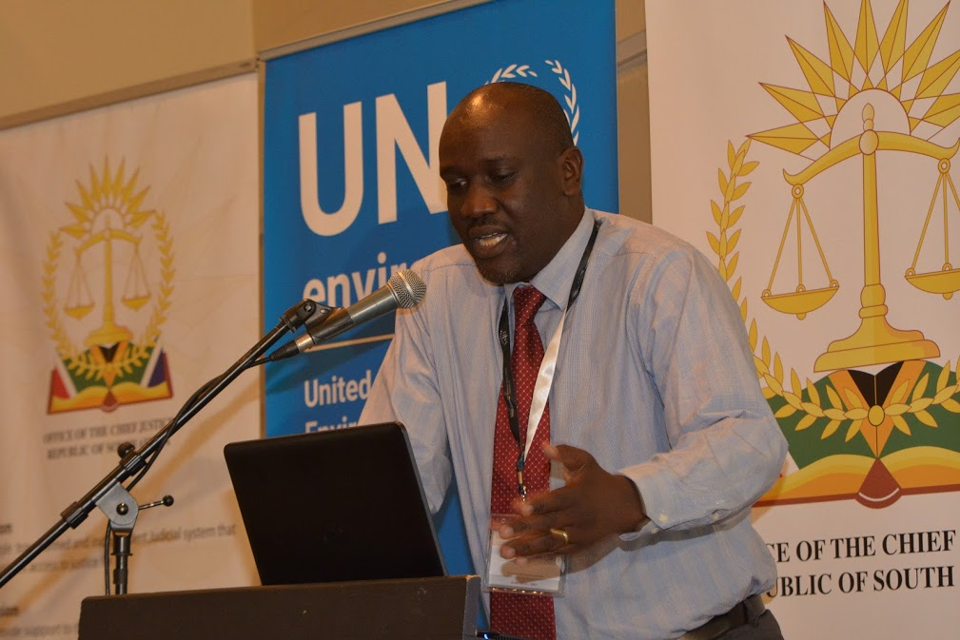
Start here
The presentation was based on the research findings undertaken by UNEP. The research showed the following as key obstacles to introduction of environmental law training programmes as funding and time, geographic position, institution inertia, resistance to new training approaches and other obstacles. The key challenge among many countries is funding. Some of the countries are incorporating the training programme in induction courses and in the existing continuous professional development. Many countries do in fact set aside funds for Judicial education and training. The absence of a formal judicial education programme on environmental law in some of the countries could act as a catalyst for the region to come together and establish a platform for the regular exchange of information, experiences and best practices in environmental law and Judicial education. Most of the environmental law training programmes are administered by either the Training Institute or the Judges Association. This is a good practice as it ensures judicial education is credible and that judicial independence is not undermined. Few countries develop their programmes on the basis of a training needs assessment. In essence therefore, the programme may not be capable of responding to concrete problems facing the continent. A radical shift is required if the environmental law training is to be expanded. The matters raised in the research study could form a good basis for developing an Africa-wide framework or guiding principles on environmental law Judicial training
8.1 DISCUSSION
The presentation was discussed as good basis to embark on cooperation between various countries. The suggestion was made that there would have to be an alignment of countries in terms of the medium, for example the Francophone or Lusophone countries. The research should be shared with relevant stakeholders in Judiciary and training institutes.
DAY 2: 26 JANUARY 2017
9. SESSION III: SUSTAINABLE INTEGRATION OF ENVIRONMENTAL LAW IN JUDICIAL TRAINING CURRICULA: SHARING OF BEST PRACTICES ON STEPS, PROCESSES, CHALLENGES AND SOLUTIONS
Panelists: Prof.Kameri Mbote, Chair Association of Environment Law Lecturers in Africa, Justice Adolfo S.Azcuna-Chancellor Phillippine Judicial Academy (Asian), Mr.Rai Muhammand Khan-Additional District & Session Judge/Senior Instructor (Pakistan) and Cesar Jorge Zunguze (Mozambique)
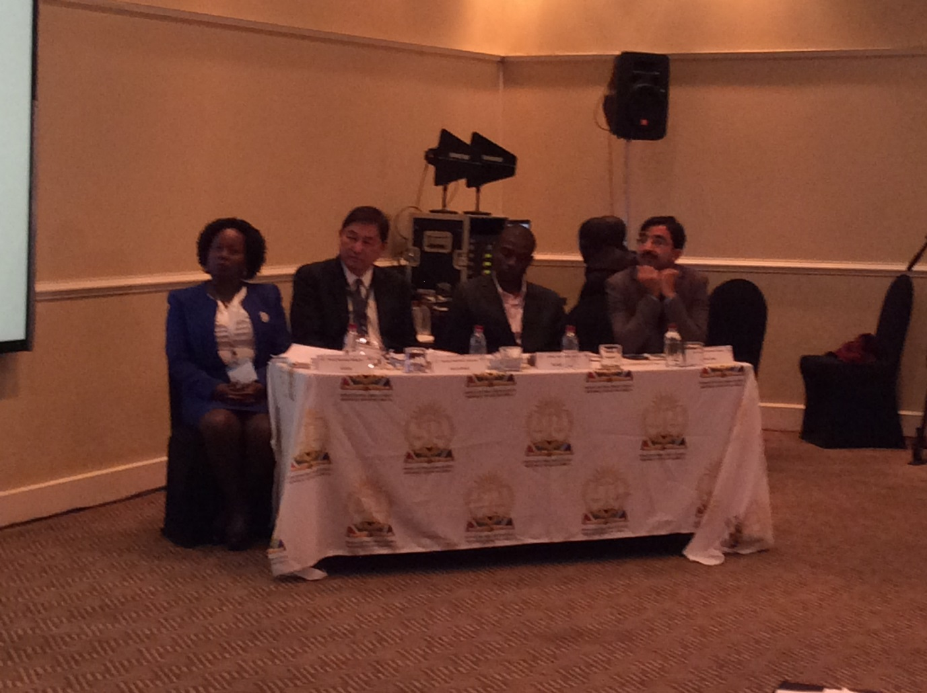
Prof.Kameri Mbote
The African experience highlighted what Environmental law lecturers have been doing in African Universities. In many universities environmental law was not taught. In the 1990’s the principles of environmental law were taught in basic courses such as administrative law, property law and constitutional law. Environmental law picked up after the UN Conference on Environment and Development in 1992. In 2013 the ICUN academy of Environmental law started building a colloquium which provided a good platform for networking amongst environmental law scholars. In the colloquium there were papers presented by academics. In conclusion the presenter advised that there is an opportunity for judicial training institutions to come together in a network and even in countries that do not have Judicial institution, the fact that there is some training going on there is opportunity to networking.
Justice Adolfo S.Azcuna
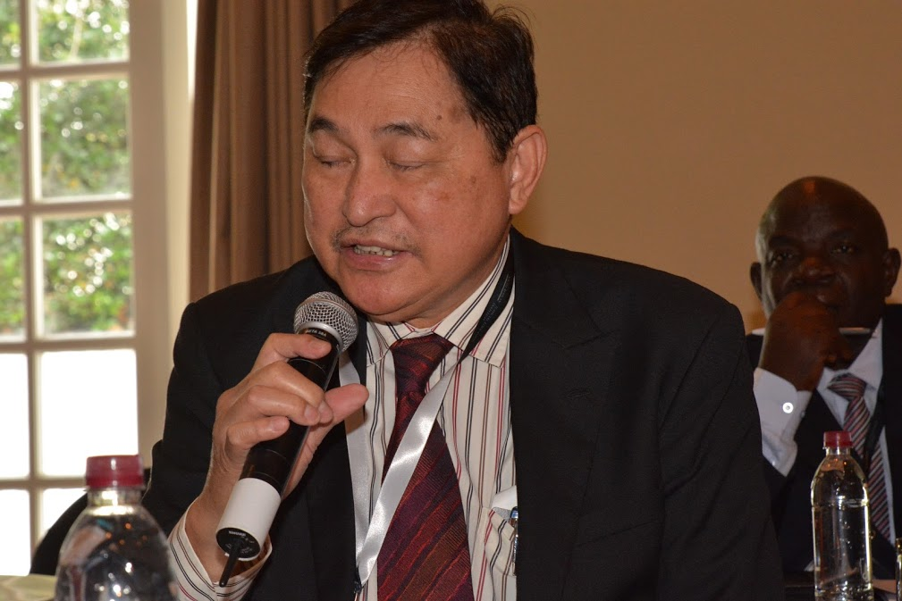
The Asian experience approach is not through training but through network by Judicial educators and the participants through the association of Chief Justices. There is an Asian colloquium on environment, and the concept of environmental justice was first tackled by this Asian Judges. The idea here is that you have to ensure rights and responsibility regarding the uses of environmental resources is distributed equally amongst the communities. In Supreme Courts there are Green Courts which administer environmental law and hold forums on environmental justice.
In Philippines, there is an overall framework which outlines environmental issues as provided by the Constitution and a number of individual laws, forestry law and laws are enacted to protect the environment from pollution. The Philippines Supreme court because of its unique power (under the Constitution) promulgate rules concerning procedures in the courts to be adopted a special rules of procedure for environmental cases. Therefore, the special rules of procedure have become an effective way of protecting the environment. The challenge is the use of Strategic Legal Action against Public Participation (SLAPP) suit. This is the suit which is filed by those who want to prevent the champions of the environment from getting effective remedies. They file a counter suit against the champions charging them with all sorts of bad motivations. There is a provision rules for environmental cases to warn the judges how to identify this SLAPP suit so that they could not in due course stood there and charge those who file them with damage in the end.
Mr.Rai Muhammand Khan
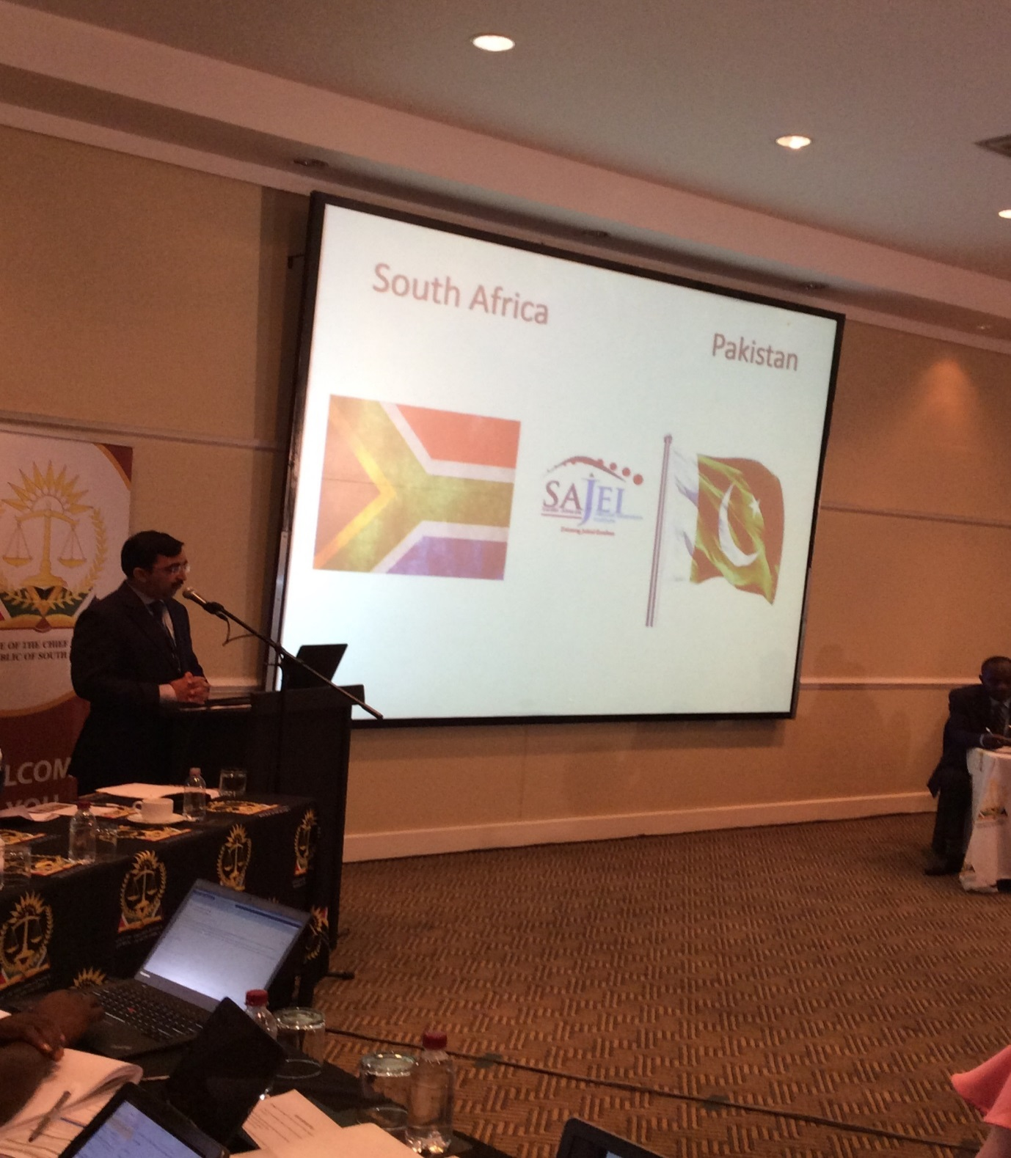
In Pakistan there is a federation, then a federal body and four other Judicial training institutes. Judges, law officers and law personnel are trained in the five institutions. In most of the academic institution there is no special training program about the environment. One major breakthrough in 2011 was a workshop for Judges on “Implementation of Environmental law”. At the Khyber Pakhtankhawa Judicial Academy has started training programme which includes environmental law training. In 2014 the academy started a programme on training judges and fortunately this has environmental part as part of the training and the aim is that by the end of 2017 all judges would have received some training on environmental law.
The Bhurban Declaration of 2012 strived for the Common Vision on Environment for the South Asian Judiciaries stipulated that training of the judiciary on environment as important for the Judges. The proposed way forward are yearly seminar at district level on environment; green desk in all academies; common goals on integration of environmental training in judicial education; regional climatic change judicial forums; and sensitization of judicial families on environment.
Cesar Jorge Zunguze
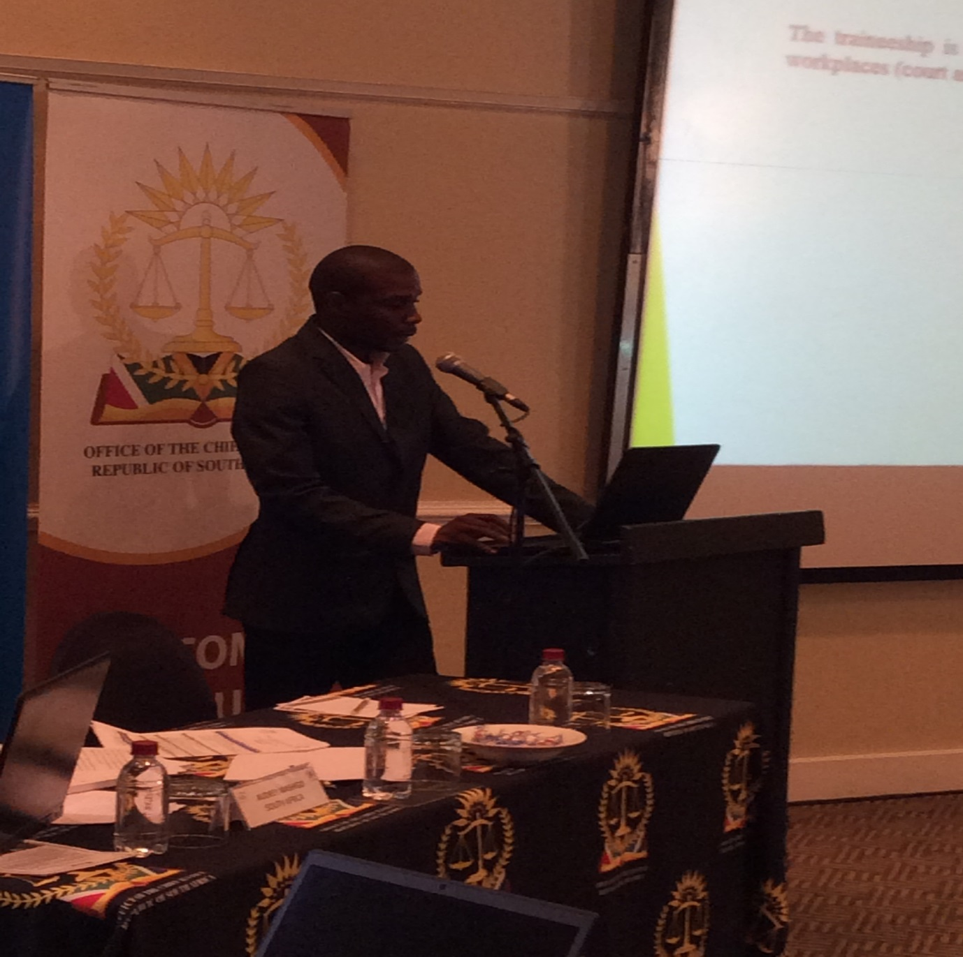
In Lusophone countries, Mozambique the right to a safe and healthy environment for the citizens is enshrined in the constitution of the Republic of each country (Mozambique, Angola, Congo) as well as the obligation to defend the environment. The right to the environment is seen as a fundamental right. Cape Verde, São Tomé e Príncipe and Guinea Bissau don’t have magistrates training centres. These countries have judicial cooperation agreements with Portugal and they benefit from trainings in various areas of law through CEJ (Centre for judicial Studies-Portugal) and their magistrates.
In Mozambique and Angola environmental law is one discipline/subject for the initial magistrates training and it has a minimum duration of 12 (twelve) months and a maximum duration of 16 (sixteen) months for theoretical and practical training. In addition a traineeship in courts and prosecutor’s office is offered for a minimum duration of 2 (two) months where participants collect experience on how to conduct proceedings evolving environmental cases. The constraints were listed as inexistence of judges and prosecutors training policies on environmental law, short time for the environmental law subject in the judiciary training institutes and short number or inexistence of specialized trainers on environmental law. These constraints development and offering of environmental law trainings. The challenges that the country faces are providing the judiciary training centres trainers with pedagogical competences, since most of them are magistrates, not teachers or educators.
9.1 DISCUSSION
The discussion included what is expected of Judges, the role they play or must play on environmental issues. Judges must make an example for their families particularly when dealing with environmental issues. The need for getting a network that works was mentioned as one of the critical factors, a network to share ideas and best practices. The concept of “Green Desk “was also emphasized by Pakistan. There must be a specific person serving at the Green Desk so as to relieve courts to focus on other matters. The last aspect that was discussed were the sentencing guidelines, in most countries there are no sentencing guidelines when it comes to environmental law. However, one of the delegate indicated that sentencing guidelines deals with all criminalized acts which encompasses everything. Therefore they cannot have sentencing guidelines and leave out environmental law. A perspective of an academic and educator was sought as to whether these environmental training for judicial officers are intended to produce experts in the field of environmental law or recognize that by the nature and breath of the judicial function, if a person is intended to preside all cases of a disciplinary nature you would need certain judicial skills to ensure that a adjudicator in those judicial matter will produce most fair and just outcome. How much do we ensure that we don’t go to extreme that to be a good judge you must be an expert in environmental law as opposed to be a good judge who is able to handle whatever subject matter. The issue of SLAPP suit was also discussed as to what it entails exactly.
10. SESSION IV: SCOPE AND CONTENT OF ENVIRONMENTAL LAW
Panelists: Hon. Sir Dennis Adjei (Ghana), Hon Gustave Dodin (Seychelles), Hon Paul Kihwelo (Tanzania) and Hon Philippe Nsoa (Cameroon)
Hon. Sir Dennis Adjei (Ghana)
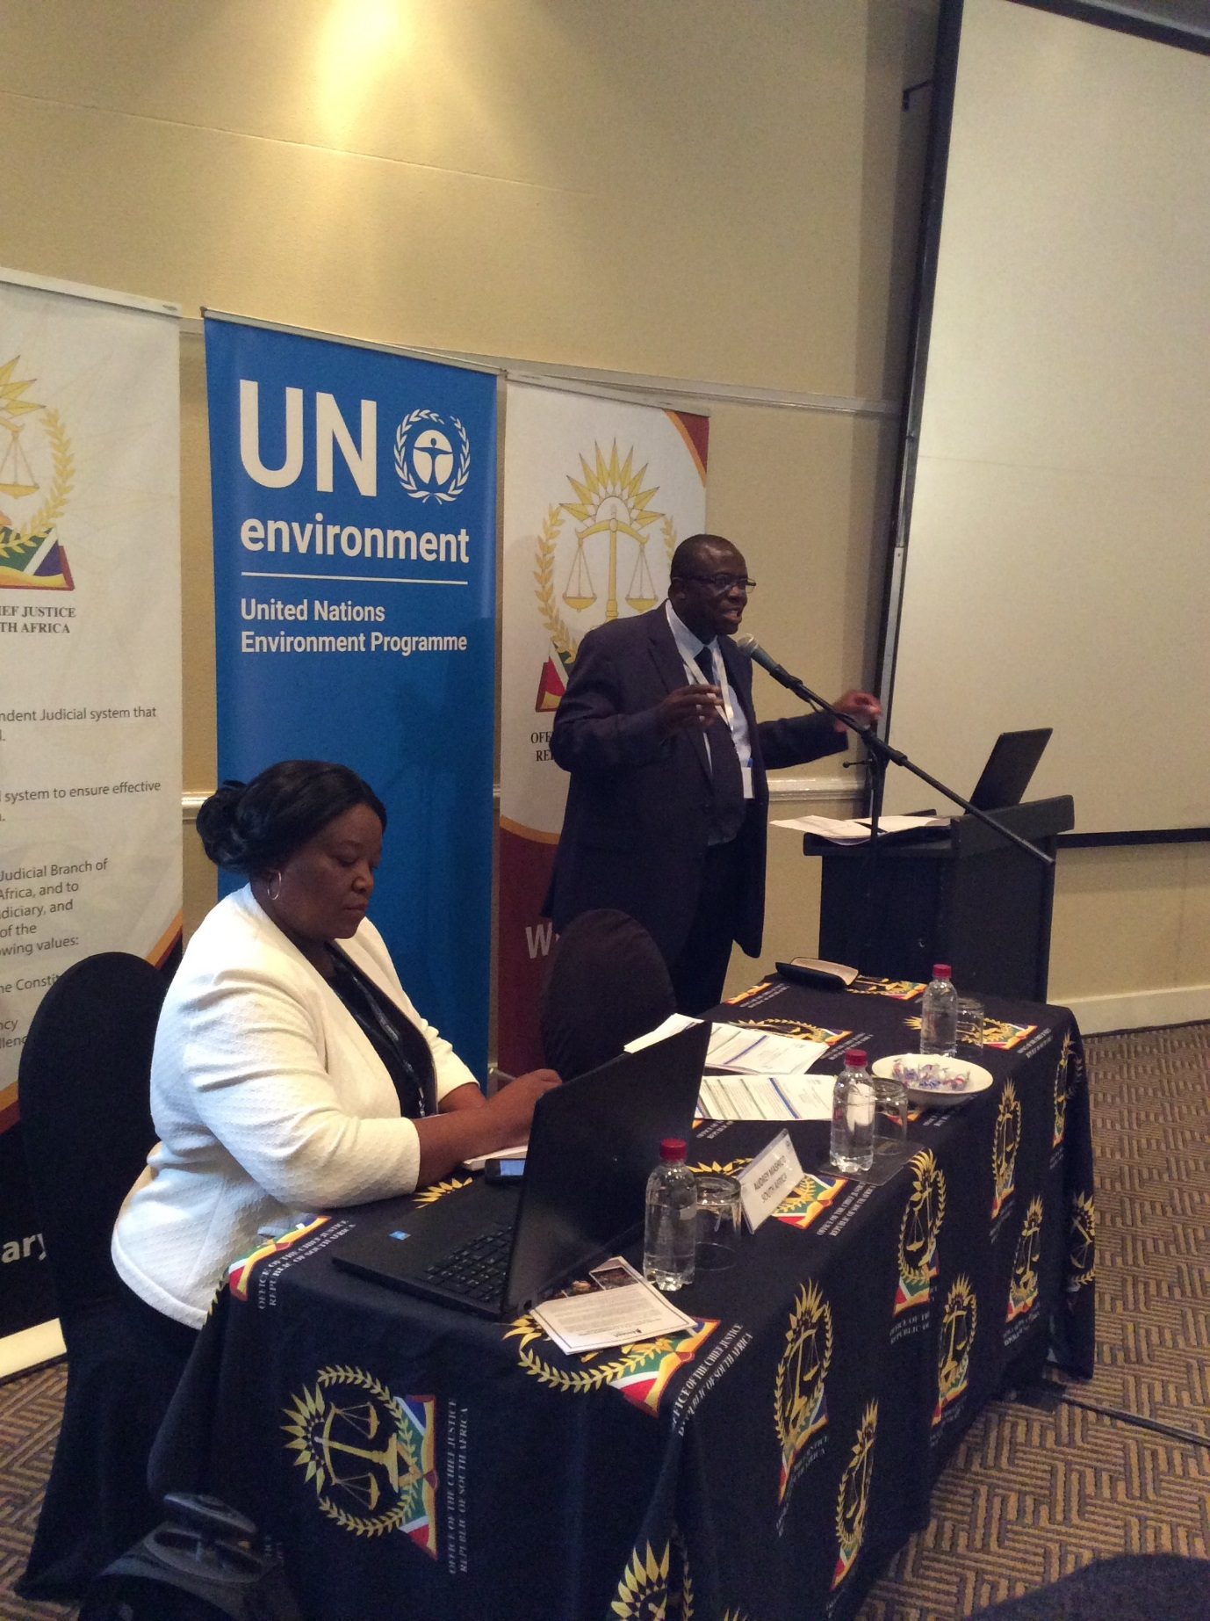
In Ghana the first law on environment law was said to have come into force in AD 80 to protect clean water for drinking in the city of Rome. In 1870’s environmental crime laws were enacted regulate sanitation. The basic concepts of environmental law are who did what, what did the person do, where did the person do it, when did the person did the act, why did the person do it and how did the person do the act. The concepts are normally referred to as who, what, where, when, why, how and thereabout. The basic concepts help to identify the person involved and the reasons for that person's act. In Ghana the basic types of environmental law are command and control legislations, (type of environmental harmful activity is determined and standards are set to prohibit that identified activity), Environmental assessment mandates (the levels of environmental impact is identified, goals are set and a standard is set to determine its viability), Economic incentives (economic instruments are used to create incentives to protect the environment) and Setting aside schemes that is protecting land and waters in their natural state. In Ghana, there is a clear distinction between international laws and domestic laws. International laws do not form part of the sources of law in Ghana unless they are either domesticated into Acts of Parliament or a resolution of Parliament is passed. Emerging issues in litigation arising from environmental law include where to site industries, cemeteries, morgues, gas stations or Fuel Service Stations, illegal Use of Chemical, the use of Genetically Modified Crops in the country and illegal mining by Ghanaians and foreigners mostly Chinese Climate change is a household word in Ghana but as a nation not much effort has been put in to address it.
There are public interest litigations which commence from the High Court. Most of them are on mining activities, where the miners fail to address environmental issues such as uncovered pits, the use of dynamite to cause harm to water bodies and the fishes and mammals living in them, mining under river beds and diversion of rivers which are the main source of drinking water for the people in rural communities and to some extend dams to provide drinking water for the people.
Hon Gustave Dodin (Seychelles)
In Seychelles The Concepts and Principles overlap and evolve with time and new concepts and new principles some into play as result of new ideas, scientific discoveries, effects of past practices and Environmental activism Traditional/Indigenous/local concepts or customs spread/evolve into national and international practices, may be enacted into laws and may be incorporated into bilateral, multilateral, regional or global/international commitments or Treaties. Environmental law exists at many levels and partly constituted by: international declarations, conventions, and treaties statutory enactments of legislative bodies, regulations generated by agencies charged by governments with protection of the environment and customary law/common law. International law binds generally states whereas national law generally binds individuals in a particular state but not always such clear demarcation. The practice of incorporating international treaties into national legislations further blurs this concept. Environmental law is not static and environmental issues cannot be considered in isolation. As more factors are identified as having some link to the state of the environment, more laws, regulations and treaties are considered. According to Article 38 the State recognises the right of every person to live in and enjoy a clean, healthy and ecologically balanced environment and with a view to ensuring the effective realisation of this right.
Hon Paul Kihwelo (Tanzania)
In the last 46 years international environmental law has evolved rapidly in Tanzania, as environmental risks have become more apparent and their assessment and management complex. In the early 20th Century, there were a few dozen multilateral agreements, and mostly countries lacked environmental legislation. To date there are hundreds of multilateral and bilateral environmental agreements and all countries have one or more environmental statutes and/or regulations. In the early day’s environmental law focused primarily on boundary waters, navigation and fishing rights. With time environmental concerns have broadened from marine pollution from oil and damage from civilian use of nuclear energy to addressing potential conflict between economic development and environmental protection. The main focus is on Environment and Development. Since the Rio Summit of 1992 the world have witnessed major developments in Environmental Law and policy. The state of environment and the danger posed Constitutional rights and obligations to protect the environment (right to clean and safe environment. Obligation to safeguard and protect the environment, water and air pollution, industrial pollution control and conservation of natural resources (pollution destroys all animal and plant life. Emerging issues on Environmental law that Tanzania is having are public interest litigation, climate change, environmental constitutionalism and forms and structure of Environmental courts and tribunals which are at increase in some countries.
Hon Philippe Nsoa (Cameroon)
In Cameroon environmental law, as far as it is concerned, is clearly seen as legal rules, which distinguishes it from wordings on environmental policy as expressed in strategies, common positions, white papers, recommendations and other policy documents. The most well-known of these concepts is that of sustainable development, enunciated in 1980 by IUCN. The phenomenon of the incorporation of international law, duly ratified and existing conventions must find a legal translation into domestic law. Either they impose themselves directly and then become national law automatically, or they require a particular legal translation in laws or regulations. Threats to the environment at the national level have been diagnosed. These are: - irrational degradation and exploitation of resources (illegal logging, illegal or unregulated mining, poor waste management, low environmental awareness on socio economic changes and impact of development activities; - pollution of air, water and soil; - waste of ecological potential. As the country is committed to achieve its goal to become an emerging country around 2035, this goes with environmental threats linked to industrialization. Another challenge is illegal poaching, no more for traditional use purpose, but for the feeding of rebel groups settled at our common borders, especially with Central Africa Republic, Nigeria and Chad.
Cameroon’s judicial organization in its present state has not yet provided for specialized courts in the environmental field. In this judicial configuration, appeals against environmental damages are brought before the administrative judge and the judge sitting both in civil and criminal matters. As far as the civil judge is concerned, while the framework law and the other Cameroonian environmental laws recognize its competence without the need to prove a fault in the event of an environmental attack, civil litigation of the environment in Cameroonian practice shows that judges are generally based on liability either for the very fact of the person or because of carelessness or negligence. As far as criminal courts are concerned, they have jurisdiction to hear disputes based on domestic and international environmental offenses. In Cameroon, the common criminal way for the settlement of disputes applies.
10.1 DISCUSSION
One delegate shared that he has an impression I have the impression that the people of Island the border of ocean are more concerned of environment issues than continental part of the country is that a wrong impression or there is something else. In addition the role of the commission composed of different expert who can give a particular opinion with regard to a specific violation of environmental law standards. An example was made by a delegate from Ghana that their constitution, article 3 provides that our fundamental human rights provisions are not limited to those in the Constitution but where we recreate and re-establish the rule of law reaching to the enforcement of fundamental rights which have been given effect by a developed country or democratic country we do not talk about domestication, where is there case of environmental nature we do not need to domesticate it. When we talk about the sea we have categories of the sea, when we talk about territorial sea it forms part of your land, when you talk about the three layers we talk about the high sea. When an offence has been committed in the high sea it does not meet a universal crime that one we will not have jurisdiction to exercise but where it falls until the economic zone you have authorization to enforce it. When we talk about environmental law standards is it permanent or not permanent, laws are there to be amended to reflect situation and address issues at any point in time that is why we have amendments, repeals and revocation of law. So when standards are set, at a point in time and you see that the standards have failed to do what they were supposed to you either amend, appeal or put on an appropriate one.
11. SESSION V: KEY CONTENT OF JUDICIARY ENVIRONMENTAL TRAINING MANUALS
Panelists: Hon Emmanuel Roberts – Sierra Leone; Mr Rex Shana – Zimbabwe; Ms Donavine Niyogere – Burundi; Mr Stephen Tiroyakgosi – Botswana; Mr Esayas Ayele - Ethiopia
Hon Emmanuel Roberts – Sierra Leone
Hon Roberts stated that there is no specific training for Judges in Sierra Leone. He further indicated the following critical aspects that needs to be taken into consideration when developing training aids on environmental law or any other topic:
- Determine whether you need a manual/bench book
- Structure of the manual: determine whether the manual has continental, sub-regional, country specific reach
- Determine whether the bench book should be electronic or hard copy format
- The content of the manual should be largely informed by needs assessment and document review
- Identify credible trainers or resource persons for the training
- Avoid facilitators who will provide skewed training
- Make sure that the training is interesting, duration not too short/long
- Identify clear objectives that will inform the training
- Use teaching aid and/or activities like film, role play, brain storming, group discussion, debates, case studies etc
- Ensure availability of tools for evaluation
Mr Rex Shana – Zimbabwe
Judicial College of Zimbabwe was established in 1999 with the responsibility of training Judges, Magistrates and administrative staff. Mr Shana provided overview of curriculum development at the college.
For detailed presentation please check http://www.judiciary.org.za/unep-colloquium.html

Ms Donavine Niyogere – Burundi
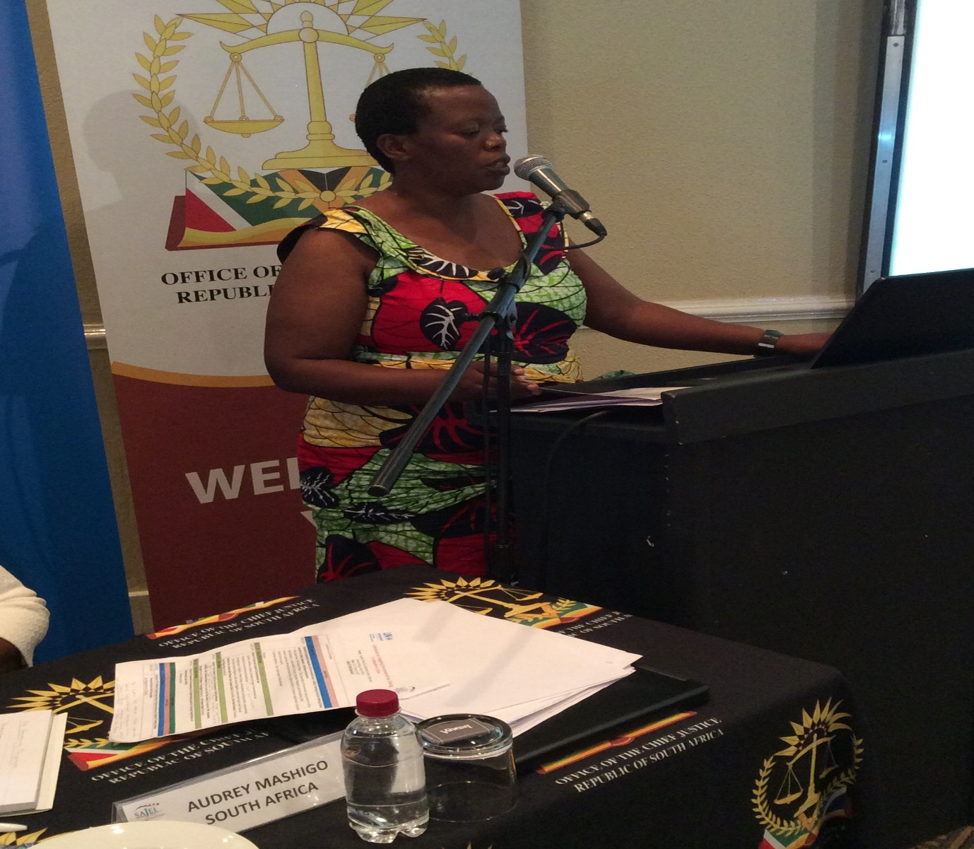
Judicial Institute was established in 2003 and operated in June 2010. The mandate of the institute is to provide continuing judicial education to judiciary, magistrates, registrars and prison staff. The institute has a partnership with the American Bank Association (ABA). The institute has developed a manual on environmental law which caters for a three days training. The manual contains general framework, principles of environmental protection as well as importance of training the judiciary which serves as a preface. www. judiciary

Mr Stephen Tiroyakgosi – Botswana
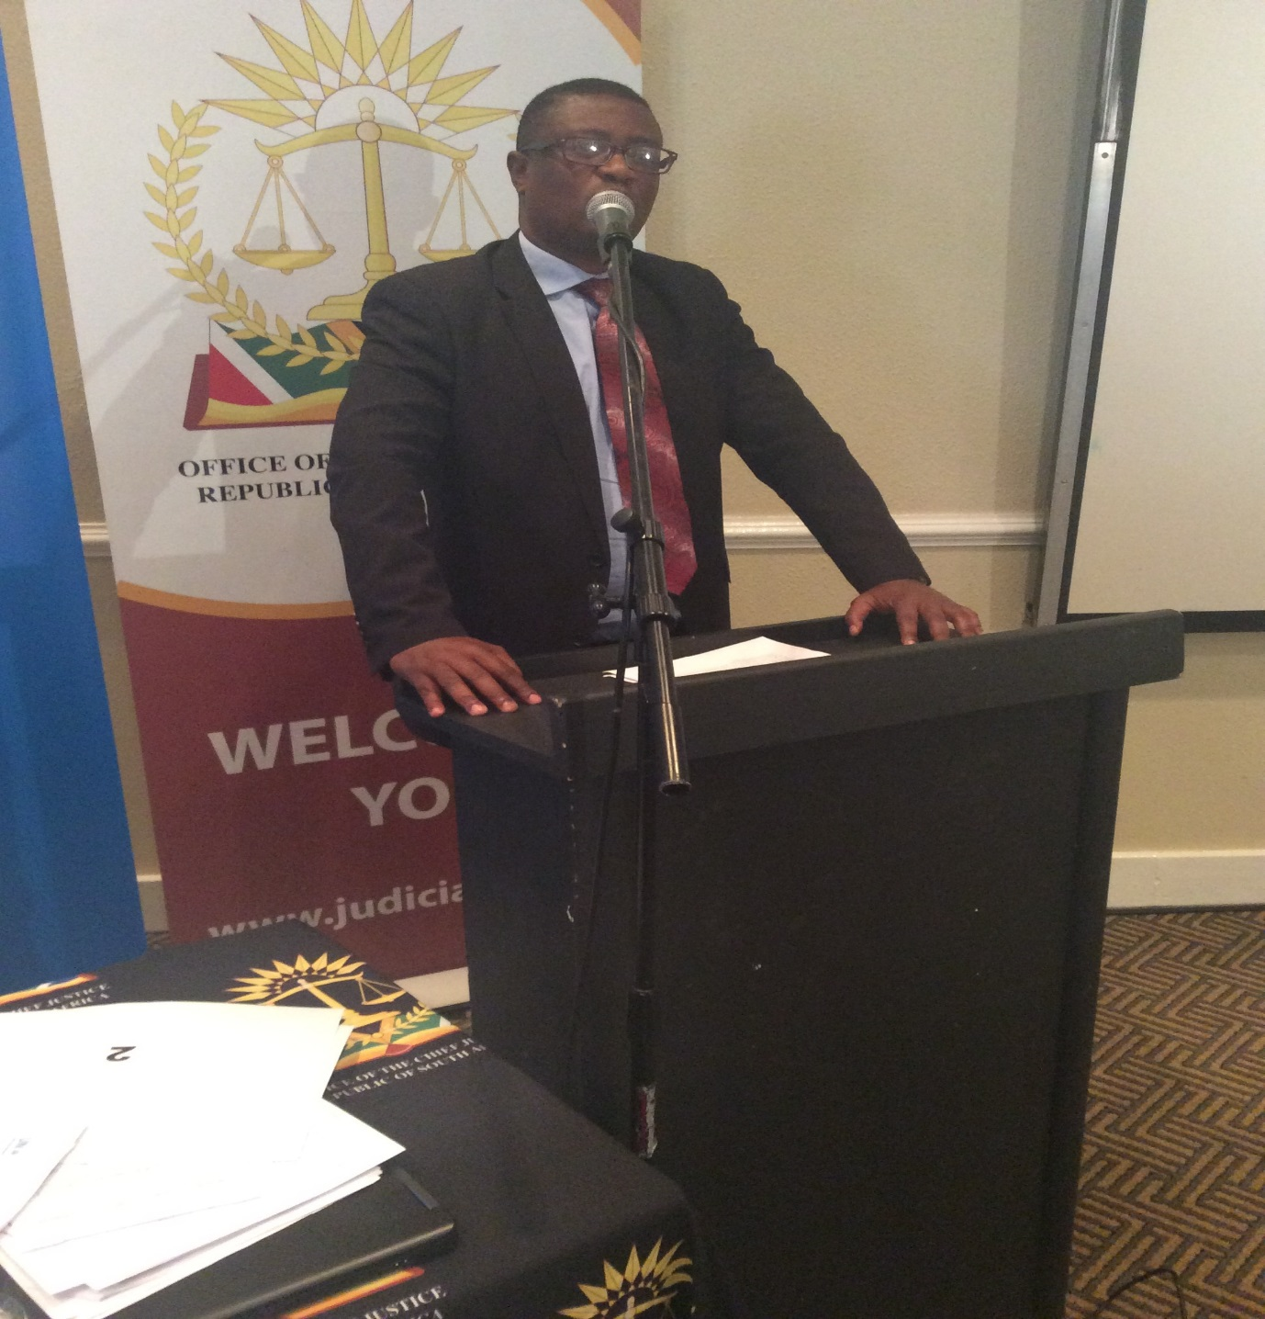
For detailed presentation please check http://www.judiciary.org.za/unep-colloquium.html

Mr Esayas Ayele – Ethiopia
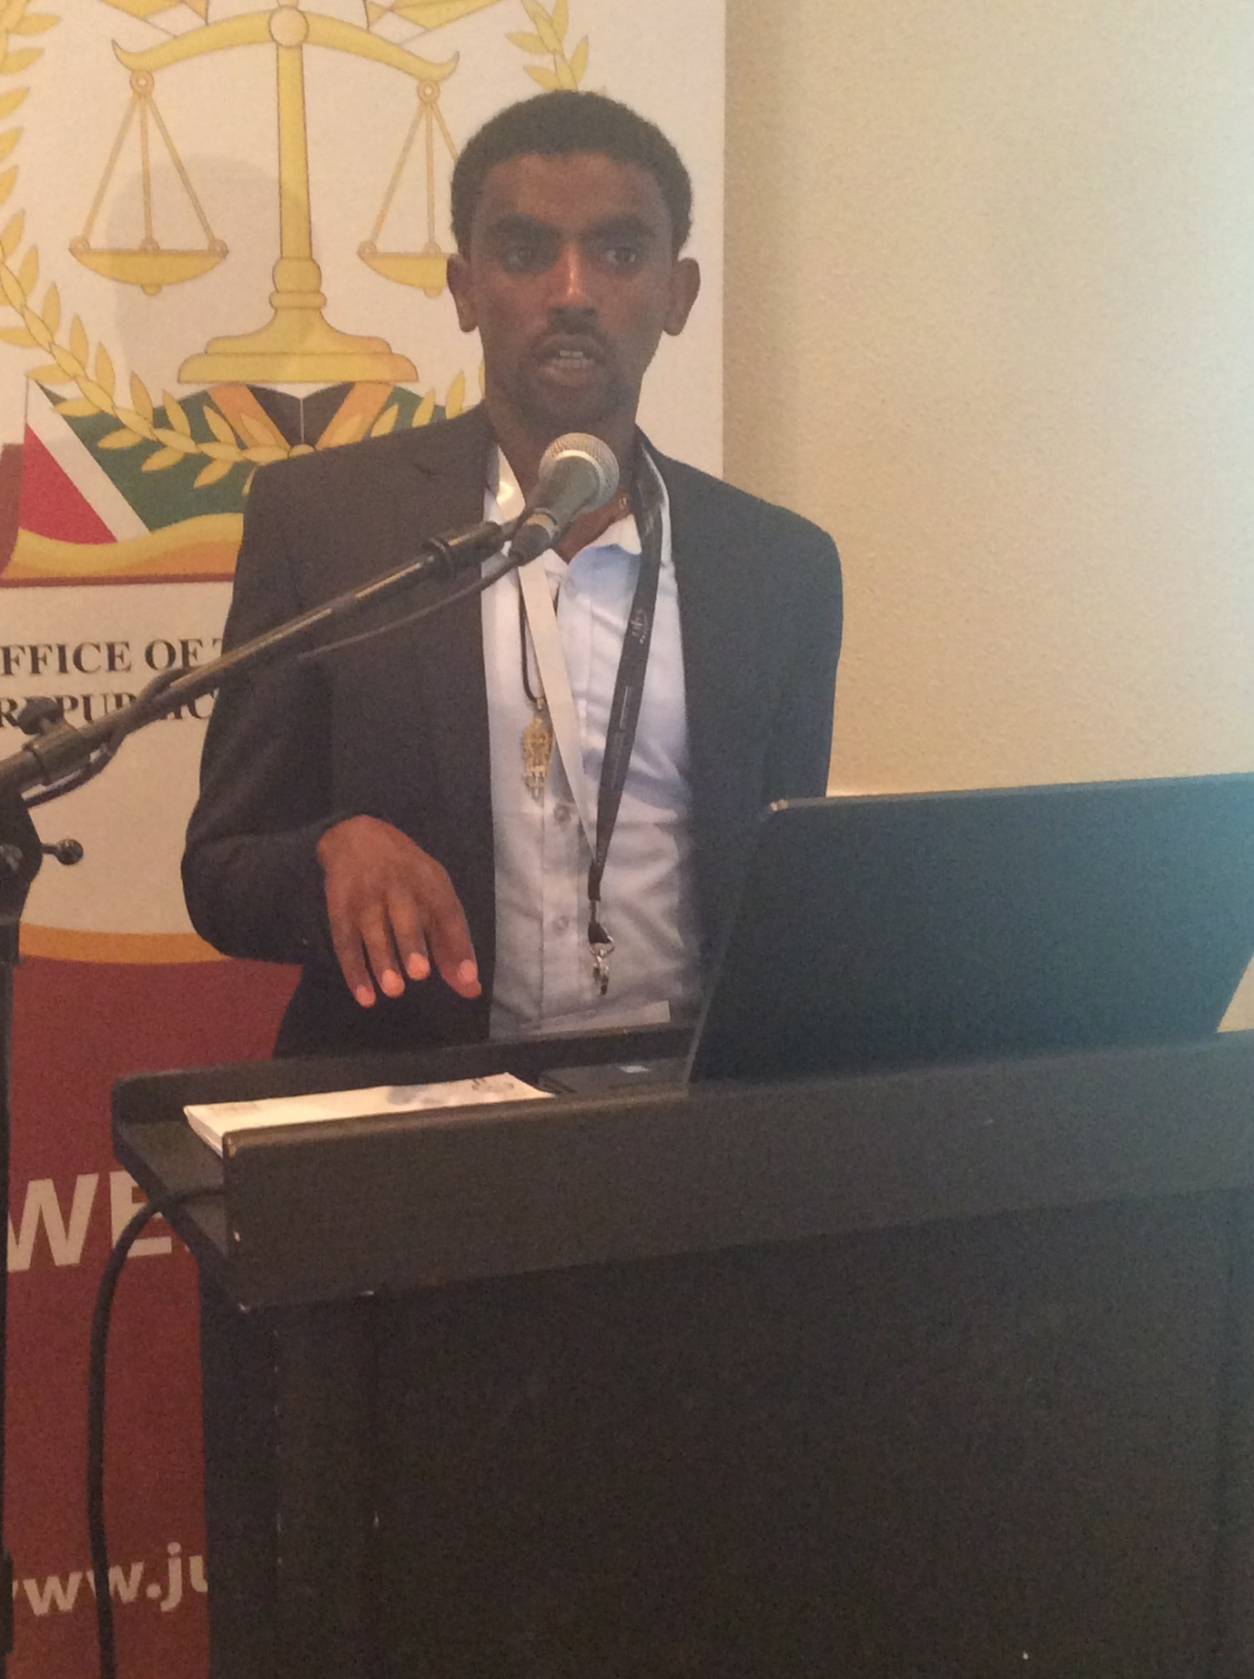
For detailed presentation please check http://www.judiciary.org.za/unep-colloquium.html

11.1 DISCUSSION
The issue of locus standi was discussed that judges must discard the issue of busy body issue and interpret locus standi eloquently, as it’s not always the truth that you can interpret it eloquently. A question about territorial jurisdiction was raised whether as a lawyer a judge can assume to preside over a matter than happens in another institution in which the law doesn’t confer jurisdiction on that matter. A suggestion was made that locus standi can actually be overcome by legislation all the African countries for example agree to change their legislation that way, in our Aviation Act it states whenever an airplane flies anywhere it still has jurisdiction over crime committed on that airplane. A similar legislation can be adopted by African countries to overcome the jurisdiction problem. Judges are there to make of all the tools of trade to come to fair conclusion. They should use experts. The judge needs to get an idea of a topic in order to make a decision, but how can I make a decision when I tell the judge this was the law. There are experts that can be used to assist judges. Another example of jurisdiction was made example that can have both civil and criminal consequences suppose that in country A, a business operator runs a business, which spills dirty water into a neighboring country as they are close to the territorial boundaries. In country B allowing that water to spill into the river then becomes a crime. Then one do you do with the originator of the crime because his located in different country. The action that started the spillage began in country A, so when you look at it in criminal law the offence cannot be punishable in country B, although it has had effect in that country B. But on the other hand when you look at the civil claim arising on the same sets of facts, the same rule will apply. That is why I say the issue of territorial jurisdiction can become very fundamental, that in one case it can apply and you don’t have to jurisdiction while you’re in a neighboring country. Under a civil claim you actually have jurisdiction so that is why I said sometimes you need to look at this very closely to see how jurisdiction can be used in the circumstances

- SESSION VI: FRAMEWORK FOR DEVELOPING AND IMPLEMENTING JUDICIAL TRAINING PROGRAMMES ON ENVIRONMENTAL LAW IN AFRICA
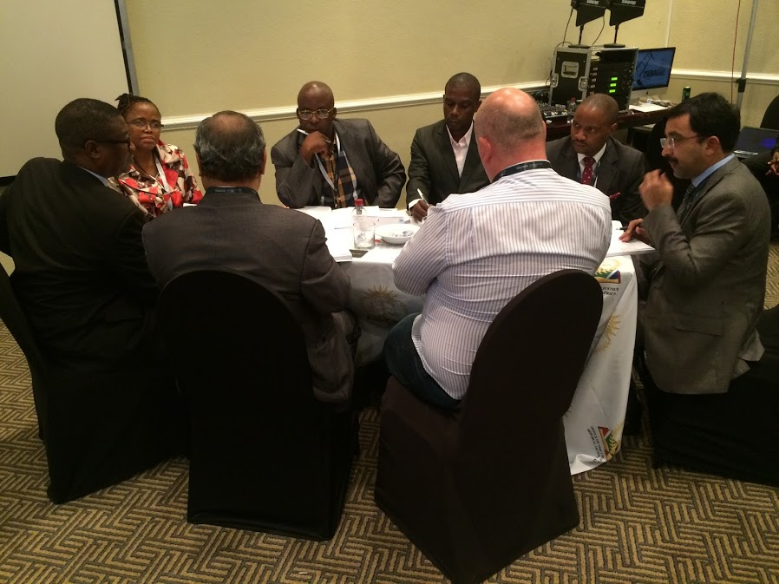
The participants were divided into six groups to discuss the Framework for developing and implementing Judicial Training Programmes on Environmental law. They had to discuss the questions indicated below and provide feedback:
- What are the key principles, objectives and actions for the Judicial training law in Africa?
- What should the Judicial education curriculum on environmental law contain?
- What are the enabling factors for developing and establishing and effective Judicial education programme on environmental law?
- Any other action needed to develop the framework/programme

DAY 3: 27 JANUARY 2017
- SESSION VII: GROUP PRESENTATIONS
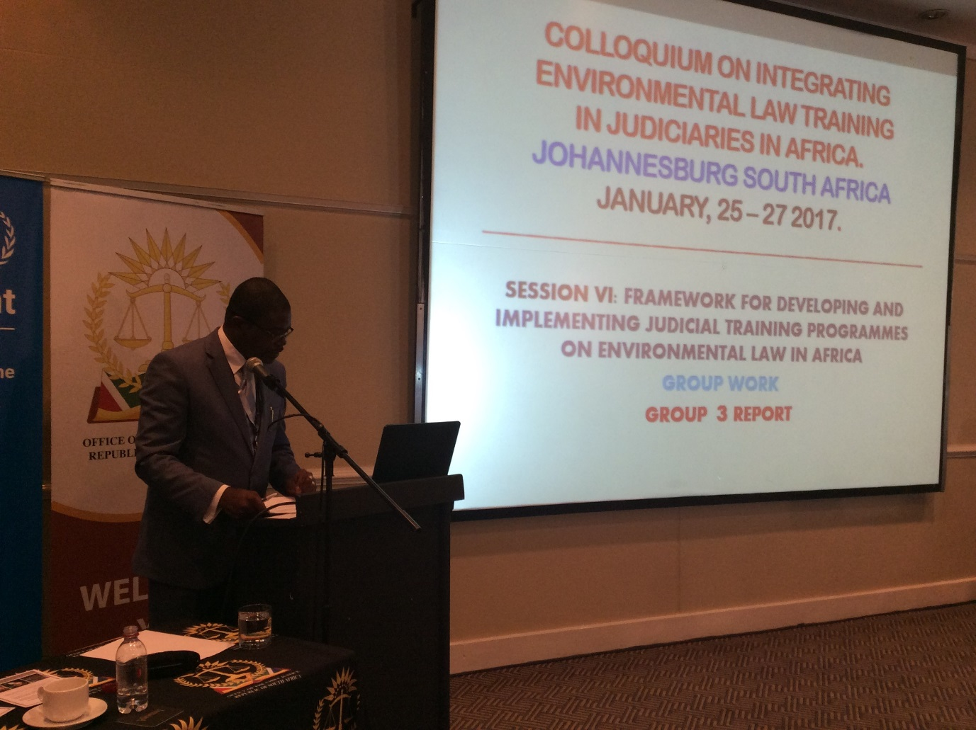
The six groups made presentation on the above questions. Visit the link http://www.judiciary.org.za/unep-colloquium.html for group presentations.
14. SESSION VIII: ACTION PLAN FOR DEVELOPING EFFECTIVE AND SUSTAINABLE ENVIRONMENTAL TRAINING PROGRAMMES FOR JUDICIARIES IN AFRICA: MR ROBERT WABUNOHA
The attached plan of action was unanimously adopted by the participants.

15. NOMINATION OF WORKING GROUP MEMBERS
The delegates agreed to elect a working group constituted as follows:
- Chairperson: Sir Dennis Adjei (Ghana)
- Secretariat: Dr Gomolemo Moshoeu (South Africa)
- Ms Mokshda Pertaub (Mauritius)
- Mr César Zunguze (Mozambique)
- Justice Otieno-Odek (Kenya)
- Dr Chifundo Kachale (Malawi)
- Justice Phillipe René Nsoa (Cameroon)
- Justice Emmanuel Roberts (Sierra Leone)
16. WAY FORWARD AND CLOSURE OF COLLOQUIUM
There are no challenges in Africa but opportunities. The milestone of the current event is that the majority of the representatives are from Judicial Training Institutes in Africa and therefore they will be able to take back the discussions to the Judiciary as well as identify gaps and make improvements where required. It is imperative that outcomes of the Colloquium should be owned by the Judiciary as they know their needs, gaps and are capable of addressing them. Now that we have developed the Johannesburg Plan of Action, the big question is what next? The colloquium should not be an ad hoc once off event rather collectively we should maintain the momentum.
