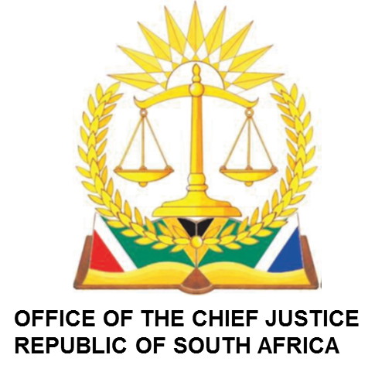

IN THE HIGH COURT OF SOUTH AFRICA MPUMALANGA DIVISION, MBOMBELA (MAIN SEAT)

FIRST CASE MANAGEMENT ROLL FOR 13 MAY 2024 at 08:30

BEFORE THE HONOURABLE JUDGE: MASHILE
JUDGE’S SECRETARY: MMATHAPELO RAMASIMONG
EMAIL ADDRESS: MRamasimong@judiciary.org.za
CIVIL COURT: 4

NO | CASE NO | NAME OF PARTIES
1. | 2990/22 | DERK DUMISANI MNISI V ROAD ACCIDENT FUND
2 | 3071/22 | PORTIA MAHLATSE MOGANE V ROAD ACCIDENT FUND
3 | 4557/19 | THANDEKA BRIDGET NKOSI V ROAD ACCIDENT FUND
BEFORE THE HONOURABLE ACTING JUDGE: MAZIBUKO
JUDGE’S SECRETARY: NKOSANA KHITSANE
EMAIL ADDRESS: NKhitsane@judiciary.org.za
CIVIL COURT: 2

1 | 783/22 | SINDI SURPRISE THEKO V ROAD ACCIDENT FUND
2 | 1442/23 | GEORGE MHLANGA V ROAD ACCIDENT FUND
3 | 1518/20 | SIPHACICO NKOSI O.B.O V ROAD ACCIDENT FUND
BEFORE THE HONOURABLE ACTING JUDGE: OOSTHUIZEN-SENEKAL
JUDGE’S SECRETARY: MAMOSHABI VIALNE
EMAIL ADDRESS: MVilane@judiciary.org.za
CIVIL COURT: 5

1 | 2610/21 | JOHANNA JAQUELINE MTHOMBENI V ROAD ACCIDENT FUND
2 | 2996/22 | AUBREY MALAPANE V THE ROAD ACCIDENT FUND
3 | 480/19 | MABASO NDODI GLADWELL V ROAD ACCIDENT FUND
4 | 4567/22 | BETHWELL SIMANGA NKOSI V MINISTER OF POLICE

