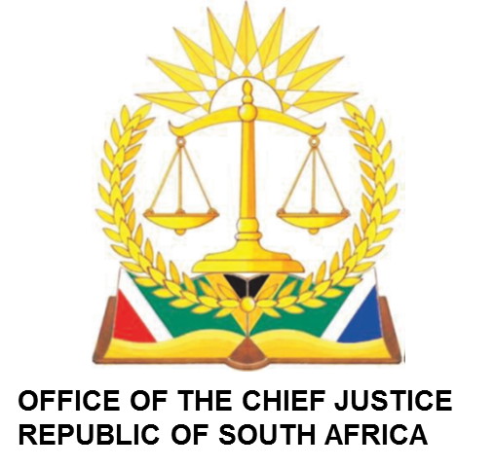

IN THE HIGH COURT OF SOUTH AFRICA MPUMALANGA DIVISION, MBOMBELA (MAIN SEAT)

FRIDAY 14 JUNE 2024
FULL COURT CIVIL APPEALS ROLL

BEFORE THE HONOURABLE JUSTICE: MASHILE ADJP
JUDGE’S SECRETARY: MATHAPELO RAMASIMONG
EMAIL ADDRESS: MRamasimong@judiciary.org.za

BEFORE THE HONOURABLE JUSTICE: MSIBI AJ
JUDGE’S SECRETARY: NKOSANA KHITSANE
EMAIL ADDRESS: NKhitsane@judiciary.org.za

BEFORE THE HONOURABLE JUSTICE: RYNEVELDT AJ
JUDGE’S SECRETARY: ITUMELENG MOFOKENG
EMAIL ADDRESS:IMofokeng@judiciary.org.za
ON PAPER
NO | CASE NO | NAME OF PARTIES
1. | A02/24 | PETERSON MERVYN HILTON +2 v/s BILLINGHAM MARGARET JESSIE + 3
 |  | To be removed
2 | A40/23 | KARMAN NOORTMAN v/s RAF
 |  | To be removed

LEGAL PRACTICE COUNCIL MATTERS

BEFORE THE HONOURABLE JUSTICE: VUKEYA J
JUDGE’S SECRETARY: MATHAPELO RAMASIMONG
EMAIL ADDRESS: MRamasimong@judiciary.org.za
And
BEFORE THE HONOURABLE JUSTICE: ROELOFSE AJ
JUDGE’S SECRETARY: INNOCENT MASILELA
EMAIL ADDRESS: IMasilela@judiciary.org.za
VIRTUAL: 10H00

NO | CASE NO | NAME OF PARTIES
1 | 5810/23 | THE SOUTH AFRICAN LEGAL PRACTICE COUNCIL v/s ISAIAH BOTSOTSO CHILOANE +1
2 | 2111/24 | THE SOUTH AFRICAN LEGAL PRACTICE COUNCIL v/s MZAMO C. MKHATSHWA
3 | 2110/24 | THE SOUTH AFRICAN LEGAL PRACTICE COUNCIL v/s NGOMANE MBONGENI NGOMANE

STOOD DOWN TRIAL ROLL

BEFORE THE HONOURABLE JUSTICE: MSIBI AJ
JUDGE’S SECRETARY: NKOSANA KHITSANE
EMAIL ADDRESS: Nkhitsane@judiciary.org.za
VIRTUAL: 09H00

NO | CASE NO | NAME OF PARTIES
1. | 4441/2023 | SHABANGU NOMCEBO OBO MINOR vs RAF
JUDGMENT: 11H00
2. | 3187/2018 | SIPHIWE MATSI vs AARON MATSI

BEFORE THE HONOURABLE JUSTICE: ROELOFSE AJ
JUDGE’S SECRETARY: INNOCENT MASILELA
EMAIL ADDRESS: Imasilela@judiciary.org.za
VIRTUAL: 11H00

NO | CASE NO | NAME OF PARTIES
1. | 2713/2023 | MNCINA NJABULO PATRIC // RAF

AVAILABLE JUDGE(S)

- MASHILE ADJP
- RATSHIBVUMO J
- REYNEVELDT AJ

