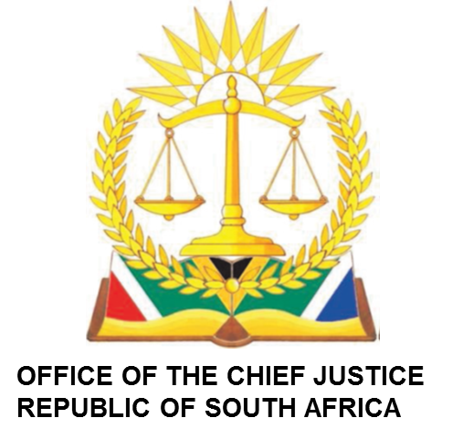

**IN THE HIGH COURT OF SOUTH AFRICA MPUMALANGA DIVISION, MBOMBELA (MAIN SEAT)**

**FIRST CASE MANAGEMENT ROLL FOR 13 JUNE 2024 at 08:30**

**BEFORE THE HONOURABLE ADJP: MASHILE**

**JUDGE’S SECRETARY: MMATHAPELO RAMASIMONG**

**EMAIL ADDRESS:** [**MRamasimong@judiciary.org.za**](mailto:MRamasimong@judiciary.org.za)

**CIVIL COURT: 4**

|  |  |  |
| --- | --- | --- |
| **NO** | **CASE NO** | **NAME OF PARTIES** |
| 1 | 4675/2022 | GWEBANE SANDILE VINCENT vs ROAD ACCIDENT FUND |
|  |  |  |
| 2 | 5098/2023 | ROSE THELMA MBAZIMA vs ROAD ACCIDENT FUND |
|  |  |  |
| 3 | 2193/2023 | NDWANDWE MARGERT vs ROAD ACCIDENT FUND |
|  |  |  |
| 4 | 345/2017 | MKHONTO NOKUTHULA GRACE vs MEC FOR HEALTH |
|  |  |  |
| 5 | 210/2024 | NENE PAMO FEZILE NONGCEBO vs ROAD ACCIDENT FUND |
|  |  |  |
| 6 | 4516/2023 | CELESTE MONDHLANE vs ROAD ACCIDENT FUND |

**BEFORE THE HONOURABLE ACTING JUDGE: MSIBI**

**JUDGE’S SECRETARY: NKOSANA KHITSANE**

**EMAIL ADDRESS:** [**NKhitsane@judiciary.org.za**](mailto:NKhitsane@judiciary.org.za)

**CIVIL COURT: 2**

|  |  |  |
| --- | --- | --- |
| **NO** | **CASE NO** | **NAME OF PARTIES** |
| 1 | 5071/2023 | NKULULEKO R LUBISI vs MINISTER OF POLICE +1 |
|  |  |  |
| 2 | 214/2023 | NGWENYA NOXOLO vs ROAD ACCIDENT FUND |
|  |  |  |
| 3 | 3539/2023 | MASINELA A YVONNE vs ROAD ACCIDENT FUND |
|  |  |  |
| 4 | 4707/2023 | MASINGA C vs ROAD ACCIDENT FUND |
|  |  |  |
| 5. | 61/2024 | MASAMBO NTHLARI NELSON vs ROAD ACCIDENT FUND |
|  |  |  |
| 6 | 716/2024 | MAGAGULA W NTOMBI vs ROAD ACCIDENT FUND |
|  |  |  |
| 7 | 576/2023 | NGUBENI N NELLY vs ROAD ACCIDENT FUND |
|  |  |  |

**BEFORE THE HONOURABLE ACTING JUDGE: RYNEVELDT**

**JUDGE’S SECRETARY: MAMOSHABI VILANE**

**EMAIL ADDRESS:** [**MVilane@judiciary.org.za**](mailto:MVilane@judiciary.org.za)

**CIVIL COURT: 5**

|  |  |  |
| --- | --- | --- |
| **NO** | **CASE NO** | **NAME OF PARTIES** |
| **1** | 4878/2022 | MLANGENI SIBONGILE SARAPHINA vs ROAD ACCIDENT FUND |
|  |  |  |
| **2** | 4187/2021 | TUMELO MASHILANE vs ROAD ACCIDENT FUND |
|  |  |  |
| **3** | 718/2022 | SOMANDLA RUPED NYUNDU vs ROAD ACCIDENT FUND |
|  |  |  |
| **4** | 4865/2021 | THEMBA X MNDAWE vs ROAD ACCIDENT FUND |
|  |  |  |
| **5** | 2845/2021 | MANDLA JOHN MASHELE vs ROAD ACCIDENT FUND |
|  |  |  |
| **6** | 714/2024 | NDUDUZO CHRISTIAN MADUBANDELA vs ROAD ACCIDENT FUND |
|  |  |  |
| **7** | 312/2024 | MOKOENA H JAPATA vs ROAD ACCIDENT FUND |
|  |  |  |